
A 10
Sreenidhi Institute of Science & Technology
(An Autonomous Institution)
Code No: 102ES02
M. TECH. I – Year II – Semester Examinations, August/September, 2011 (Regular)
CMOS ANALOG & MIXED SIGNAL DESIGN (VLSI & Embedded Systems)

Time: 3 Hours Max. Marks : 60

Note : No additional answer sheets will be provided.

* * * * *
Part-A (Objective Type)
Max.Marks:10

Answer all the QUESTIONS.

1. Why cascode connections are used in current mirrors.

2. Draw the voltage divider circuit using CMOS transistors?

3. How input impedance is affected by the negative feedback?

4. How to recognize feedback topologies.

5. Define Common Mode Range "CMR" & Common Mode Rejection Ratio.

6. Define PSRR & Output Offset Voltage.

7. Draw the symbol of differential output Op-Amp using two single ended Op-Amps.

8. Write about the operation of basic comparator & Draw its DC characteristics.

9. Write about charge injection?

10. Find the resolution for a DAC if output voltage is desired to change in 1 mv increments while using a ref. voltage of 5V.

Part – B (Subjective Type)
Max. Marks: 50
Answer any Five. All questions carry equal marks.

1. a) Explain the operation of cascode current source for lower minimum voltage
across the current source? [ 5 ]

b) Design a current sink using V_{DD}= - V_{SS} = 2.5 V to sink a current of 10μA with CN20 process. Estimate the minimum voltage across current source and the output resistance? [ 5 ]

2. a) Derive the expressions for A_{OL}, A_{CL}, R_{inf} and R_{of} of transistor level series - shunt feedback amplifier? [ 5 ]

b) Calculate the gain, V₀/V_{s} of the trans-impedance amplifier as shown in figure below. Assume A = 5,00,000 V/A, R_{i}=10Ω and R₀=10 Ω. [ 5 ]
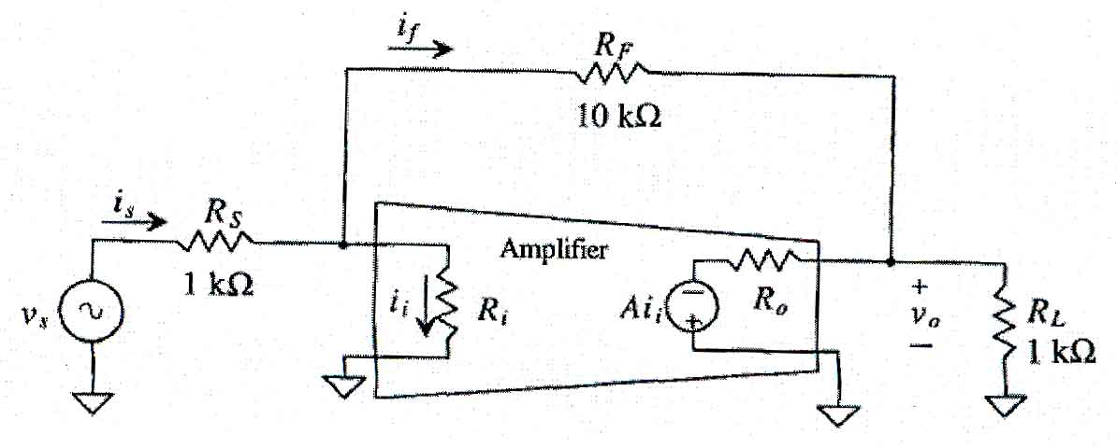

3. a) Explain the operation of source coupled differential amplifier? [ 5 ]
b) Define CMRR & derive the expression for CMRR of a differential amplifier using
MOSFET? [ 5 ]
4. a) Explain the operation of operational Trans-Conductance amplifier and derive the expression for its transfer gain? [ 5 ]
b) Explain the characteristics of an Op-Amp ? [ 5 ]
5. a) Explain the operation of clocked comparator based on basic latch? [ 5 ]
b) Explain about Adaptive Voltage Follower with neat diagrams? [ 5 ]
6. a) Explain the operation of current steering DAC with neat diagrams? [ 6 ]
b) Design a 3-bit DAC using a R-2R architecture with R = 1 K Ω, R_{F} = 2K and
V_{REF}= 5V. [ 4 ]
7. Write notes on any two [ 5 + 5 ]
a) CMOS Comparator b) Adaptive Biasing c) Charge Scaling DAC's
-- 00 -- 00 --

